BACHELOR’S DEGREE CERTIFICATE
Li Xiao-yan, female, born on August 12, 1986, has studied in Liaocheng University with a speciality of Bioscience. Upon completing and passing all the required courses of the 4-year undergraduate program, she is granted graduation. In accordance with the academic degree act of the People’s Republic of China, the aforesaid student is awarded the Bachelor’s Degree in Science.

XXXXX
Chairman of
Degree Appraising Committee of
Liaocheng University

Date: June 23, 2008
Certificate No.: 1234567890123456
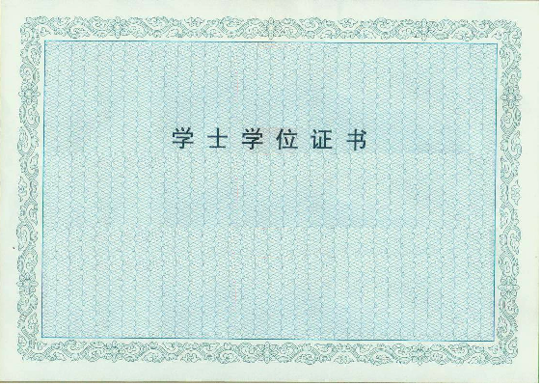

证书原件扫描

CERTIFICATE OF GRADUATION
Li Xiao-yan, female, born in August 1983, has completed her 4-year undergraduate program in Bioscience in Liaocheng University from September 2004 to July 2008. Upon completing and passing all the required courses, she is qualified to graduate.

XXXXX
President of
Liaocheng University

Date: July 12, 2007
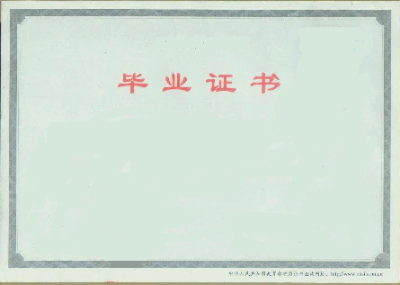
Certificate No. :1234567890123456
证书原件扫描

